VELOX System - Software Testing & QA Report
Project Name: VELOX Logistics & Delivery System
Track: Software Testing & Quality Assurance
Team Members:
- Abdelrahman
- Nabeeh
- Fady
- Raheek
- Hoda
Date: September 2026
1. Static Testing & Code Review
In this section, Static Testing (code review without execution) was performed on the core classes of the VELOX system to evaluate code quality, exception handling, and input validation:
- Validation in Delivery Classes: Verified that the Delivery class effectively validates invalid package weights (less than or equal to 0) and throws an IllegalArgumentException to prevent logical calculation errors.
- Exception Handling in Return Service: The ReturnService class handles return policy rules properly by utilizing the custom ReturnPolicyException to enforce the allowable return window (24 hours).
- Boundary Value Check: The return condition relies on calculating days via ChronoUnit.DAYS to evaluate the time difference between orderDate and the current time.
- 2. Test Cases Specification Table
- Structured test case specifications designed for system testing and integration into Jira:
Test Case ID | Test Title & Type | Pre-conditions / Test Steps | Input Data | Expected Result
TC-01 | Successful Order Return  (Dynamic) | 1. Create an order with today's date.  2. Call processReturn(order). | orderDate = Current Time  isReturned = false | Return is accepted successfully, isReturned becomes true, and the refunded amount is returned within a Response object.
TC-02 | Delivery Price Calculation  (Dynamic) | 1. Instantiate a ClothesDelivery object.  2. Call calculatePrice() method. | Zone = DAMIETTA  weight = 4.0 kg | Total Price = 70.0 EGP (60 EGP base zone rate + 10 EGP extra weight fee).
TC-03 | Order Packaging Check  (Static/Dynamic) | 1. Add products to the order.  2. Call PackagingService.packageOrder(order). | Order contains a product named "Laptop" | Products are iterated, packaged, and logged without throwing errors (Null Pointer Exception).

3. Dynamic Unit Testing (JUnit Implementation)
The JUnit 4 library dependency was integrated into pom.xml to set up automated unit testing.
Test Class Source Code (ReturnServiceTest.java):
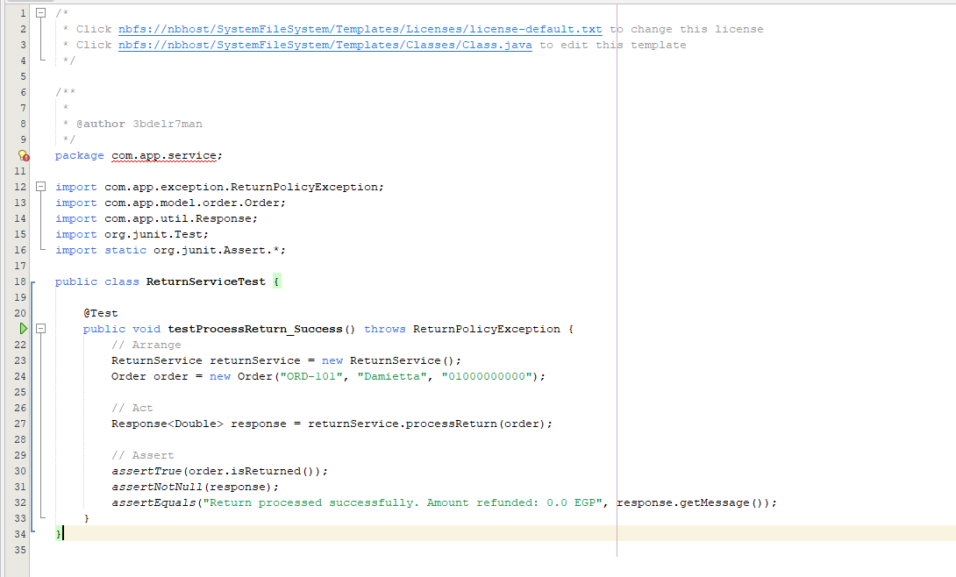

4. Test Execution Results & Build Proof
Unit tests were executed using the Maven Surefire Plugin with the following build execution output:
- Test Class: com.app.service.ReturnServiceTest
- Tests Run: 1
- Failures: 0
- Errors: 0
- Build Status: BUILD SUCCESS
